Scenario: 1To validate data type for in CMM xml for the following field-

TotalPurchQty (18,3), TransactionAmt(18,2)

JSON Message-

{"partner_id":"3005","participant_id":"3001234567891030025","discnt_amt":0.698,"fuel_grade_cd":"001002003004005006007","fuel_pump_id":"001002003004005006007","non_fuel_purchase_amt":0.345,"partner_transaction_id":"123456789 123456789 123456789 123456789 12345","postal_cd":"59722","promotion_price_amt":0.453,"purchase_discnt_limit_amt":0.21,"purchase_uom_cd":"GAA","recon_error_type_cd_set":"0007","recon_status_cd":"00005001234","regular_price_amt":0.345,"safeway_settlement_amt":0.865,"site_id":"3112267895 3112267895","tender_type_code":"0","total_fuel_purchase_amt":0.656,"total_purchase_amt":33.765,"total_purchase_qty":3.3464,"total_savings_val_amt":0.697,"transaction_id":"2400456134","txn_fee_amt":0.120758,"txn_net_payment_amt":0.569259,"account_unit_nbr":"6710800","account_number":"392805","create_ts":"2021-04-22T11:34:59.487Z","create_user":"integration","modified_ts":"2021-04-22T11:34:59.487Z","modified_user":"integration"}

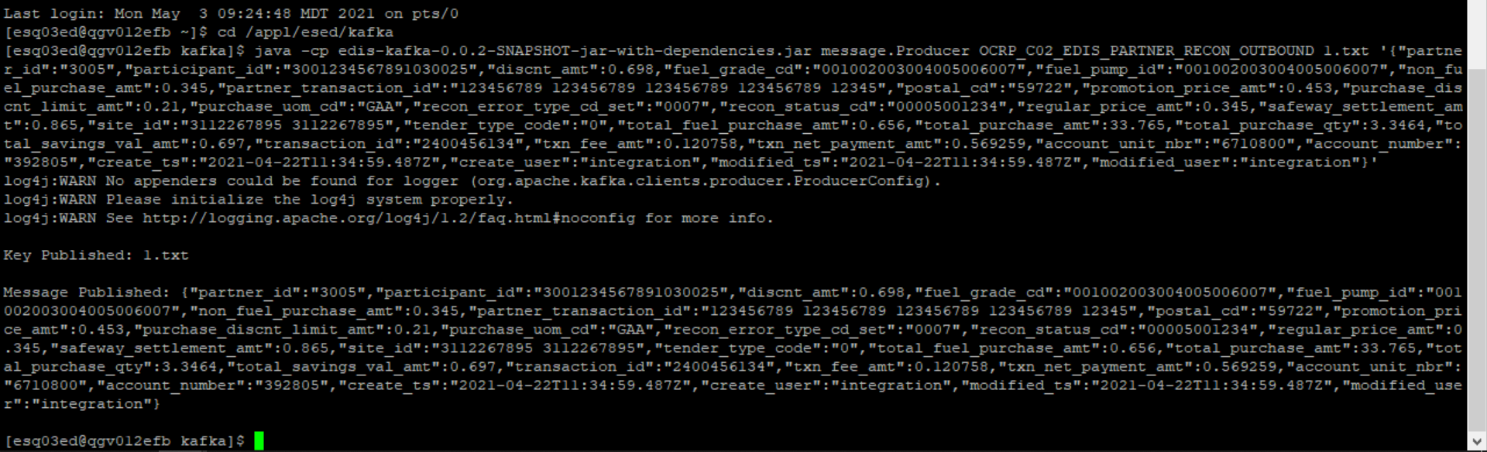



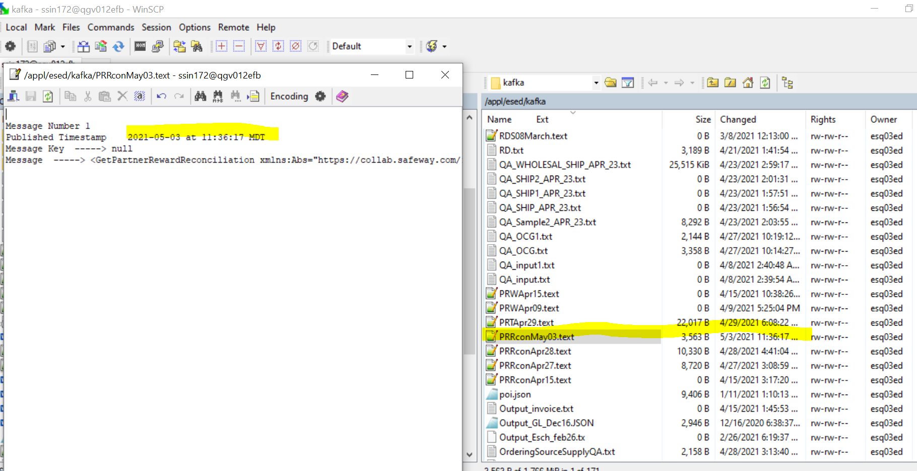

TotalPurchQty (18,3), TransactionAmt(18,2)

CMM XML-

<GetPartnerRewardReconciliation

xmlns:Abs="https://collab.safeway.com/it/architecture/info/default.aspx">

<DocumentData>

<Document VersionId="v1.2.1" SystemEnvironmentCd="QA">

<Abs:DocumentID>OCRP_C02_EDIS_PARTNER_RECON_OUTBOUND</Abs:DocumentID>

<Abs:AlternateDocumentID>OCRP_C02_EDIS_PARTNER_RECON_OUTBOUND_0_12_20210503113617207717</Abs:AlternateDocumentID>

<Abs:DocumentNm>PartnerRewardReconciliation</Abs:DocumentNm>

<Abs:CreationDt>2021-05-03T11:36:17.207717</Abs:CreationDt>

<Abs:Description>PartnerRewardReconciliationData</Abs:Description>

<Abs:SourceApplicationCd>OCRP</Abs:SourceApplicationCd>

<Abs:TargetApplicationCd>EDIS</Abs:TargetApplicationCd>

<Abs:InternalFileTransferInd>Y</Abs:InternalFileTransferInd>

<Abs:DataClassification>

<Abs:DataClassificationLevel>

<Abs:Code>Internal</Abs:Code>

</Abs:DataClassificationLevel>

<Abs:BusinessSensitivityLevel>

<Abs:Code>Low</Abs:Code>

</Abs:BusinessSensitivityLevel>

<Abs:PHIdataInd>N</Abs:PHIdataInd>

<Abs:PCIdataInd>Y</Abs:PCIdataInd>

<Abs:PIIdataInd>Y</Abs:PIIdataInd>

</Abs:DataClassification>

</Document>

<DocumentAction>

<Abs:ActionTypeCd>UPDATE</Abs:ActionTypeCd>

<Abs:RecordTypeCd>CHANGE</Abs:RecordTypeCd>

</DocumentAction>

</DocumentData>

<PartnerRewardReconciliationData>

<Abs:PartnerId>3005</Abs:PartnerId>

<Abs:TransactionType>

<Abs:TransactionId>2400456134</Abs:TransactionId>

<Abs:AltTransaction>

<Abs:AltTransactionId>123456789 123456789 123456789 123456789 12345</Abs:AltTransactionId>

</Abs:AltTransaction>

</Abs:TransactionType>

<Abs:PartnerSiteId>3112267895 3112267895</Abs:PartnerSiteId>

<Abs:PartnerParticipantId>3001234567891030025</Abs:PartnerParticipantId>

<Abs:PostalZoneCd>59722</Abs:PostalZoneCd>

<Abs:StatusType>

<Abs:StatusCd>00005001234</Abs:StatusCd>

</Abs:StatusType>

<Abs:RewardReconciliation>

<Abs:FuelPumpId>001002003004005006007</Abs:FuelPumpId>

<Abs:FuelGradeCd>

<Abs:Code>001002003004005006007</Abs:Code>

</Abs:FuelGradeCd>

<Abs:ReconErrorTypeCd>

<Abs:Code>0007</Abs:Code>

</Abs:ReconErrorTypeCd>

<Abs:TotalPurchQty>3.346</Abs:TotalPurchQty>

<Abs:PurchUOMCd>

<Abs:Code>GAA</Abs:Code>

</Abs:PurchUOMCd>

<Abs:TenderTypeCd>

<Abs:Code>0</Abs:Code>

</Abs:TenderTypeCd>

<Abs:PurchDiscLimitAmt>

<Abs:TransactionAmt>0.21</Abs:TransactionAmt>

</Abs:PurchDiscLimitAmt>

<Abs:RegularPriceAmt>

<Abs:TransactionAmt>0.34</Abs:TransactionAmt>

</Abs:RegularPriceAmt>

<Abs:PromoPriceAmt>

<Abs:TransactionAmt>0.45</Abs:TransactionAmt>

</Abs:PromoPriceAmt>

<Abs:TotalSavingValAmt>

<Abs:TransactionAmt>0.70</Abs:TransactionAmt>

</Abs:TotalSavingValAmt>

<Abs:TotalFuelPurchAmt>

<Abs:TransactionAmt>0.66</Abs:TransactionAmt>

</Abs:TotalFuelPurchAmt>

<Abs:NonFuelPurchAmt>

<Abs:TransactionAmt>0.34</Abs:TransactionAmt>

</Abs:NonFuelPurchAmt>

<Abs:TotalPurchaseAmt>

<Abs:TransactionAmt>33.76</Abs:TransactionAmt>

</Abs:TotalPurchaseAmt>

<Abs:DiscountAmt>

<Abs:TransactionAmt>0.70</Abs:TransactionAmt>

</Abs:DiscountAmt>

<Abs:TxnFeeAmt>

<Abs:TransactionAmt>0.12</Abs:TransactionAmt>

</Abs:TxnFeeAmt>

<Abs:TxnNetPymtAmt>

<Abs:TransactionAmt>0.57</Abs:TransactionAmt>

</Abs:TxnNetPymtAmt>

<Abs:SettlementAmt>

<Abs:TransactionAmt>0.86</Abs:TransactionAmt>

</Abs:SettlementAmt>

<Abs:AccountData>

<Abs:AccountId>392805</Abs:AccountId>

<Abs:AccountingUnitId>6710800</Abs:AccountingUnitId>

</Abs:AccountData>

</Abs:RewardReconciliation>

<Abs:AuditData>

<Abs:CreateUserId>integration</Abs:CreateUserId>

<Abs:UpdateTs>2021-04-22T11:34:59.487Z</Abs:UpdateTs>

<Abs:UpdateUserId>integration</Abs:UpdateUserId>

</Abs:AuditData>

</PartnerRewardReconciliationData>

</GetPartnerRewardReconciliation>